**1.Introduction**

**1.1 Bank system background**

For simulation, I have chosen Lloyds Bank, which is one of the banks with the largest number of customers in the UK. The queues often seen in a crowded city like Cardiff gave us the basis for our simulation to analyze bank queues and make our own assumptions.

In this simulation, I have not only analyzed and explained queues in the bank based on real data, but more importantly, I have put forward our proposals to eliminate these queues.

**1.2 Objective of the simulation**

The main goal of our simulation is to by utilizing the collected data into the Simul8 software, better analyze the queues, prevent service delays in the bank, and achieve customer satisfaction.

In the context of concerns regarding long queues at Lloyds Bank, our simulation emerges as a valuable tool for uncovering solutions. The insights gained from the simulation have the potential to guide practical measures aimed at reducing customer wait times and improving the overall operational efficiency of the bank. This endeavor aligns with the broader objective of making meaningful contributions to Lloyds Bank's operational effectiveness and ensuring a positive customer experience.

1.3Process of bank queue system

The process is shown in the flowchart.

2.Data collection and analysis

2.1Data collection method

In order to create this model a lot of data is required. This includes: Inter arrival Time, waiting time ATMS and counter tables, service time for ATMS and counter tables, queue capacity,

The below table shows the snapshot of our data collected(in minutes)

|  |  |  |  |  |  |
| --- | --- | --- | --- | --- | --- |
| Customer Number | Inter arrival time | Waiting time for ATM | service time for ATM | Waiting time for counter table | Service time for counter table |
| C1 | 0.00 | 0 | 0.50 | 15.00 | 11.00 |
| C2 | 4.00 | 0 | 0.50 | 7.00 | 21.00 |
| C3 | 2.33 | 0 | 1.50 | 17.00 | 23.33 |
| C4 | 8.83 | 0 | 0.33 | 12.00 | 23.08 |

Data was gathered using a hybrid approach, conducting interviews with the bank branch manager and making observations within the bank. The data collection spanned two weeks, with observations conducted for approximately 4 hours each day from Monday to Sunday.

Initially, I interview the bank branch manager to explore the possibility of obtaining relevant data and to seek permission for data collection. After observation, I discovered that the peak hour in the bank was around 11am to 15pm, additionally, during peak hours, there are approximately 4 staff working in the bank, one of which is serving as reception staff, another 3 are serving at counter table.

Subsequently, our focus shifted to collecting inter arrival times ,representing the time intervals between customers entering the bank. To ensure precise timing, I employed stopwatch to record times for each new customer. Furthermore, I collected data on the time customers spent in each queue and the time used for service both for ATMS and counter tables. These timings were later transferred to excel for analysis and were useful for fitting distribution and simulating models.

2.2Data analysis and visualization

There are generally 5 steps for data analysis which is conducted by using R language.

2.2.1 Data import

In the initial phase, the focus was on the incorporation of the essential R package 'fitdistrplus' and subsequent loading of the dataset. The dataset includes five columns which are customer ID, inter arrival time, waiting time for ATM, service time for ATM, waiting time for counter table and service time for counter table.

2.2.2 Raw data analysis

Following the dataset incorporation, a strategic visualization strategy was employed, employing boxplots to portray the distribution characteristics of pivotal variables. Horizontal boxplots provided an intuitive representation, enabling the discernment of median values, interquartile ranges, and the identification of potential outliers. The boxplot is helpful to identify how many outliers are there in each column of data. The figure1 shows the range of data dispersion and identify outliers for inter arrival time, serving time for ATM, waiting time for counter table and service time for counter table. From the chart, it can be observed that the mean value for the 4 different time based distribution is around 2 minutes, 1 minute, 2 minutes and 5 minutes respectively, and these features can be used in the data cleaning process.

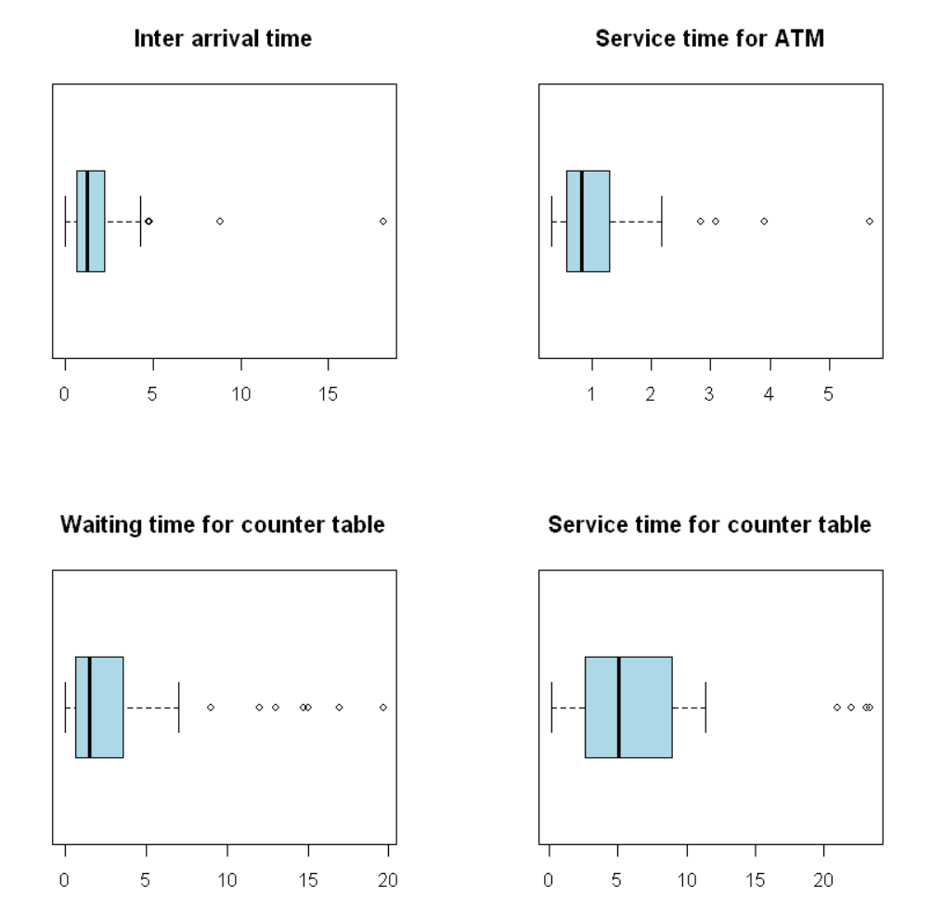

2.2.3 Data cleaning

After identifying the outliers, A custom function in R, denoted as 'replace_with_mean,' was introduced to manage outliers systematically by substituting them with the mean value of the respective variable. This proactive approach addressed the potential detrimental impact of outliers on statistical analyses and model fitting, enhancing the overall representativeness of the dataset and mitigating the influence of extreme values.

2.2.4 Distribution fitting and selection

The subsequent phase involved the application of the 'fitdist' function to model distributions for each variable, accompanied by the computation of AIC (Akaike Information Criterion) values. AIC, serving as a model selection criterion, judiciously balances model complexity with goodness of fit to the dataset. The selection of the distribution boasting the lowest AIC value ensued, signifying the optimal fit that effectively characterized the dataset. This meticulous process guaranteed the chosen distribution's efficiency and conciseness in encapsulating pertinent data features. In R, the ‘fitdist’ function is used to fit the distribution and calculate the AIC value.

The following histograms visualize the distribution of inter arrival time, service time for ATM, waiting time for counter table and service time for counter table from the dataset.

The table shows the AIC value for different distributions.

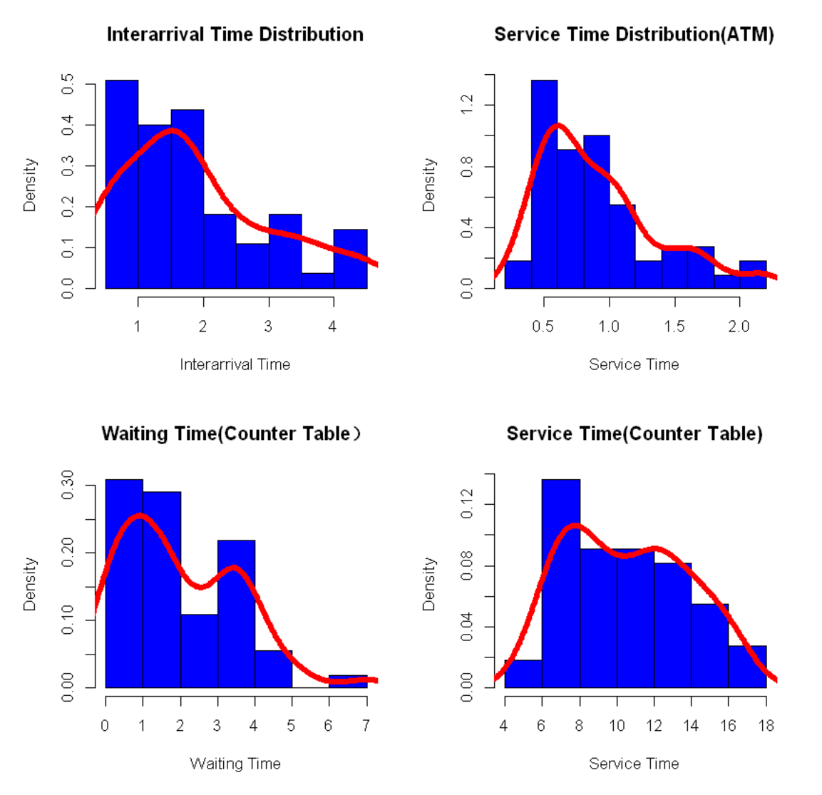

|  |  |  |
| --- | --- | --- |
| Type | Distribution | AIC Value |
| Inter arrival time | Normal | 173.14 |
| Gamma | 160.19 |
| Exponential | 182.45 |
| Service time for ATM | Gamma | 42.27 |
| Normal | 52.54 |
| Exponential | 96.07 |
| Waiting time for counter table | Exponential | 188.15 |
| Gamma | 190.09 |
| Normal | 210.09 |
| Service time for counter table | Exponential | 300.47 |
| Normal | 287.03 |
| Gamma | 285.91 |

2.2.4.1 Inter arrival time

The inter-arrival time conforms to a gamma distribution, yielding an AIC value of 160.19. In comparison, the AIC value for the normal distribution and exponential distribution are 173.14 and 182.45.

2.2.4.2 Waiting time for ATM

Based on on-site observations, it has been determined that the waiting time for ATM transactions falls within the range of 0 to 1 minute. Consequently, for the purposes of this paper, the waiting time for ATM transactions has been standardized to a fixed value of 0.5 minutes.

2.2.4.3 Service time for ATM

Regarding the service time for ATM transactions, the gamma distribution emerges as the preferred model with an AIC value of 42.27. In contrast, both the normal and exponential distributions yield higher AIC values (52.54 and 96.07, respectively).

2.2.4.4 Waiting time for counter table

For waiting time of counter table, the exponential distribution again stands out as the optimal choice with an AIC value of 188.15. In comparison, the normal distribution exhibits a higher AIC value of 210.09. This indicates that the exponential distribution provides a more suitable framework for characterizing the waiting time at the counter table.

2.2.4.5 Service time for counter table

For the service time at the counter table, the gamma distributions outshine the normal and exponential distribution. The gamma distribution yields an AIC value of 285.91, while the gamma exponential and normal distribution have lower AIC values of 300.47 and 287.03, respectively.

2.2.5 Parameter estimation

Parameter estimates for the selected distributions were calculated through ‘fitdist’ function by using ‘$estimate’ to extract the parameters. The parameters are shown in the following table.

|  |  |  |
| --- | --- | --- |
| Type | Distribution | Parameters |
| Inter arrival time | Gamma | α = 4.17 β =1.60 |
| service time for ATM | Gamma | α = 4.65 β =5.10 |
| waiting time for counter table | Exponential | λ=0.5 |
| service time for counter table | Gamma | α = 2.24 β =0.4 |

3.System simulation

After completing the data collection and analysis, and obtaining all the necessary distributions, I proceeded to develop our simulation model. Initially, I created a comprehensive flowchart illustrating the entire process of customers entering the bank, conducting their transactions, and leaving the bank. Subsequently, I translated this process into the Simul8 software.

I constructed two models. The first model was based on the observed real-life situation at the bank, providing a representation of the existing processes. The second model was developed based on scenarios designed to optimize service times and allocate additional resources, ultimately enhancing the efficiency of the entire banking system.

3.1Model description

After individuals enter the bank, they are directed into two separate queues. One queue is designated for those intending to use the ATMs, while another queue is established for those seeking assistance with various services, such as withdrawals, deposits, and transfers. A reception staff member equipped with a tablet assists individuals who have pre-booked specific services through the bank's online system before joining the transaction queue. Additionally, three service counters are available for individuals to conduct their transactions.

3.2Model assumptions

* Peak hours during 12:00pm – 4:00pm on all days from Monday to Friday
* The bank's reception staff will assist customers in the check-in process using tablets, and the allotted time for this service is set at an average of 2 minutes.
* The time distributions for each activity are mutually independent. This implies that the duration of one activity, such as the inter-arrival time, is not correlated with the time needed for another task. Given this independence, I structured our data collection across multiple days, each dedicated to gathering specific types of data.

3.3System input parameters

I delineate the key input parameters that govern the behavior of our simulation model. These parameters are fundamental components influencing the dynamics of the system. These inputs are crucial for accurately replicating real-world scenarios within the Simul8 environment. The identified system input parameters and values in this system are as follows :

Arrival rates: The frequency at which customers arrive at the bank within an hour is 38.

Service time: The average service time I observed at the bank is 1minute for ATM, 5minutes for service table.

Resource allocation: The number of check-in staff is 1 . The number of counter table is 3 , The number of ATM machine is two.

Customer type (work type): Customers are categorized by age, with labels distinguishing between regular (type 1) and elder customers (type 2).

Business type (transaction type): Three observed transaction types are deposits, withdrawals, and transfers, each distinguished by labels.

Queue capacity: The maximum number of customers the system can accommodate in the waiting queue is 50, calculated based on the available seats in the bank lobby

3.4Model simulation

In the first model, there are 7 activities, namely start point, reception staff, ATM and counter table.

3.4.1 Start point

Start point marks the point where customer first go in to the bank, from the previous data analysis, it follows the exponential distribution by assessing the inter arrival time which show the time taken between customers entering the bank. From observation, it is discovered that people aged over 60 takes 20% and the business type in the bank can be divided into three categories which are deposit(40%), withdraw(40%) and transfer(20%).

3.4.2Queues

There are two main queues in this simulation, one of which is used for waiting ATM service, another queue is generated for counter table service.

3.4.3ATMs

Two ATMs are used in the bank whose service time follows Gamma distribution.

3.4.4Reception staff

One reception staff works at bank lobby. This activity follows fixed distribution with parameter to be 1.

3.4.5Counter table

Three counter tables are used. Different techniques are used to fit the data into distributions. For the first counter table, machine learning technique is involved to set the timing predictions. Second table use timing by labels of business type. The third uses the regular data fitting methods as shown in the previous section.

3.5Model function

3.5.1Start point

7 simulation functionalities are used in this project.

Five(visual logic) features are used in start point: distribution, create distribution , routing out, labels and visual logic. Two labels which named Business type and work type are set up to distinguish different age group and people conducting different business, to assign the correct value to work unit by distribution observed, new probability profile distributions are created. Routing out feature is used to direct people from start point to different queues for ATM service and counter service, the routing out percentages are 10% and 90% respectively based on observations.

3.5.2Queues

Queue property are edited: (1)editing queue shelf time as ### .(2) min wait time to###. (3)Capacity is set to be 60 at the counter table queue based on the capacity of bank lobby.

3.5.3Counter table

Timing via machine learning: Machine learning technique is used to calculate the time customer spend in a counter table based on their characteristics such as age and business type. To incorporate machine learning into the simulation, python is employed to train the algorithm and formulate the routing rules that Simul8 would utilize. The data is imported into python, model is trained using the preinstalled linear regression function lm(). Then simul8 can assign the machine learning generated distribution to the counter table activity.

Timing by labels: For the second counter table, I set average service time 3mins, 3mins and 8mins for business type deposit, withdraw and transfer.

3.5.4Resources

Four staff are available as resources and assigned to reception and counter tables.

4.Experiments and results

Numerous insights were gleaned from the execution of a discrete event simulation in Simul8, shedding light on the overall efficiency of bank queuing system and the waiting times in queues. This research involved running multiple models with varying resource allocations to comprehensively assess the system.

4.1 Current bank system simulation

Upon completing the simulation, the obtained results provide a snapshot of the current waiting times for customers and the utilization of bank staff. Notably, resource in ATM area is fair utilized with average waiting time for ATM queue is less than 1 minute, while resources in the counter table exhibit signs of overutilization, and the maximum waiting time in queues is capped at 37.85 minutes.

4.2 System validation

Initially, I undertook a meticulous verification of our model using Visual Verification through the Simul8. I cross-referenced the number of arrivals and with the provided dataset, revealing a near-identical count of arrivals in our model. Subsequently, data is calculated the based on the results obtained from our simulation model, including the number of work items entered the start point(122), the average waiting time in queues of counter table(9minutes), and the average time for customer spend in the bank(26.15minutes) . The resulting value of those closely aligns with the mean of the real data derived from the collected real-life dataset. This logical verification process, coupled with the validation of our model, fortifies the robustness of our approach. These findings were meticulously examined, shared, and subsequently validated with the collected data, confirming their optimality.